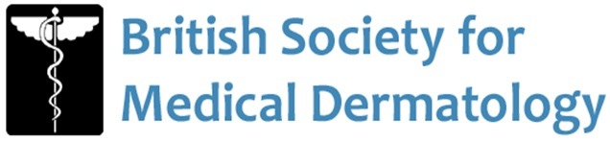

Regional Medical Dermatology Training Days Proposal Form

Proposer Information

Name of proposer:
Address:
Telephone:
Email:

Training Day Information

Title:
Date:
Venue:
Programme

Please attached a copy of your proposed programme (with speakers) and summarise below the intended objectives of the day

Further Information
Is this a new event?
Have you applied for CPD points and if so from whom

Who are your intended audience?
What are your expected attendance numbers?
What is your intended delegate fee?
Do you have any current/intended sponsors? | Yes |  | Exclusively No Other funding*
 | NB: * Please refer to guidelines for further details

If the application is successful, please provide details of preferred method of transfer of funds

Please include any additional information that you feel supports your proposal

Return the completed form via email to fionatasker@doctors.org.uk by 5pm 31st July 2024

Please note that applications will only be accepted via email and those received after the deadline will not be eligible for review.

Notes to applicants

Please refer to the Regional Medical Dermatology Educational Day Proposal Guidelines when completing your proposal form.

Your application will be considered by the BSMD and you will be informed of the decision as soon as possible.

Please note all applicants are required to strictly adhere to the terms and conditions stated in the guidelines.

I confirm I have read the guidelines and I will comply with the terms and conditions stated.

Signature: Date:

Print Name: Position:

